How to enable the Virtualization in GCP

1. Download and install Gcloud command line tool sdk software.

Ref link

<http://www.brianlinkletter.com/enable-nested-virtualization-on-google-cloud/>

2. gcloud init

3. gcloud compute images create nested-virt --source-image-project=ubuntu-os-cloud --source-image-family=ubuntu-1604-lts --licenses=<https://www.googleapis.com/compute/v1/projects/vm-options/global/licenses/enable-vmx>

Output :

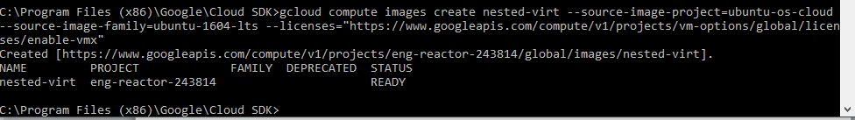

Now we will install virtuall box:

4.install docker

bash <(curl -Ls <https://raw.githubusercontent.com/ypmn/ypmn-k8s/master/scripts/docker-install.sh>)

Install virtualbox ………………

Ref Link

<https://websiteforstudents.com/virtualbox-5-2-on-ubuntu-16-04-lts-server-headless/>

sudo apt-get update && sudo apt-get dist-upgrade && sudo apt-get autoremove

sudo apt-get -y install gcc make linux-headers-$(uname -r) dkms

wget -q https://www.virtualbox.org/download/oracle_vbox_2016.asc -O- | sudo apt-key add -

wget -q https://www.virtualbox.org/download/oracle_vbox.asc -O- | sudo apt-key add -

sudo sh -c 'echo "deb http://download.virtualbox.org/virtualbox/debian $(lsb_release -sc) contrib" >> /etc/apt/sources.list'

sudo apt-get update

sudo apt-get install virtualbox-5.2

VBoxManage -v

curl -O http://download.virtualbox.org/virtualbox/5.2.4/Oracle_VM_VirtualBox_Extension_Pack-5.2.4-119785.vbox-extpack

sudo VBoxManage extpack install Oracle_VM_VirtualBox_Extension_Pack-5.2.4-119785.vbox-extpack

VBoxManage list extpacks

$ base=https://github.com/docker/machine/releases/download/v0.16.0 &&

curl -L $base/docker-machine-$(uname -s)-$(uname -m) >/tmp/docker-machine &&

sudo install /tmp/docker-machine /usr/local/bin/docker-machine

Above commands Ref Link

<https://docs.docker.com/machine/install-machine/>

Now its time to create virtual box…

Ref Links:

<https://github.com/crops/docker-win-mac-docs/wiki/Windows-Instructions-(Docker-Toolbox)>

<https://docs.docker.com/get-started/part4/#configure-a-docker-machine-shell-to-the-swarm-manager>

docker-machine create --driver virtualbox myvm1

docker-machine create --driver virtualbox myvm2

docker-machine ls